|  |  |
| --- | --- |
|  | FPT ACADEMY INTERNATIONAL  FPT – APTECH COMPUTER EDUCATION |

Center Name: ACE-HCMC-2-FPT

Address: 590 Cach Mang Thang Tam Street, District 3, Ho Chi Minh City, Viet Nam



Online Help Desk

Design Document

|  |  |  |  |
| --- | --- | --- | --- |
| Faculty: | | Mr. Tran Phuoc Sinh |  |
| Batch No: | | T11708A0 |  |
| Group No: | | 07 |  |
| Student: |  | Full Name | Roll No. |
|  | 1. | NGUYEN HOANG TU | STUDENT1054235 |
|  | 2. | NGUYEN THANH NAM | STUDENT1057514 |
|  | 3. | TRAN VAN THANG | STUDENT1053909 |

October, 2018

Mr. Nguyen Hoang Tu

Mr. Nguyen Thanh Nam

Mr. Tran Van Thang



This is to certify that

have successfully designed and

developed 

Submitted by:

Date of Issue: ________

Authorized Signature: ___________



# Table of Contents

Table of Contents 2

I. Acknowledgments 6

II. Problem Definition 7

1. Introduction 7

2. Existing Scenario 7

3. Requirement Specification 7

1.1. Administrator 8

1.2. Facility Heads (Staffs) 8

1.3. Assignees (Staffs) 8

1.4. End-user 8

4. Hardware / Software Requirements 9

III. Task sheet review 1 9

I. Architecture & Design of the Project 12

1. Presentation Tier: 13

2. Business Logic Tier: 13

3. Data Access Tier: 13

II. Algorithms - Data Flowchart: 13

Symbol generates: 13

1. Login process: 14

2. Log out: 15

3. Create new user (Admin only): 16

4. View list of user account (Admin): 17

5. Search specific user account: 17

6. View detail, block/unblock & delete user (Admin only): 18

7. Reset to default password for specific user (Admin only): 19

8. Create new facility (Facilities head): 20

9. Block/unblock & delete facility (Facilities head): 21

10. View list of all requests (Facilities head): 22

11. Send request to assignee (Facilities head): 22

12. Close/Reject request (Facilities head & assignee): 23

13. Create request (End-user): 24

14. Cancel request (End-user): 24

III. Data flow diagram (DFD): 25

1. Context level diagram: 26

2. Level 1 DFD: 27

3. Level 2 DFD: 28

3.1. Administrator manages end-user accounts: 29

3.2. Administrator manages staff accounts: 30

3.3. Administrator handles registration accounts: 31

3.4. Facilities head (staff) manages facilities: 31

3.5. Facilities head (staff) manages request: 32

3.6. Assignee (staff) manages request: 32

3.7. End-user manages request: 32

IV. Use Case Diagram 33

1. Administrator Use Case: 34

2. Facilities Head Use Case: 35

3. Assignees Use Case: 36

4. End-user Use Case: 37

V. Sequence Diagram 38

1. Login 41

2. Logout 43

Change Profile 44

3. Insert( Admin) 46

4. Update (Admin) 48

5. Delete ( Admin) 50

6. Delete User ( Admin) 52

7. Student ( User) send request 54

VI. Entity Relationship (E-R) Diagram 56

Entity 56

E-R Diagram: 59

VII. Class Diagram 60

VIII. Task sheet review 2 61

I. Database Design: 63

1. Database design diagram: 63

2. Structure diagram: 64

II. GUI Designs – Front End: 68

1. Home page: 68

2. Register page: 70

3. End-user logged in page: 71

3.1 Request list: 71

3.2 Create new request: 72

3.3 End-user profile: 73

3.4 Change password: 74

4. Facilities head logged in page: 75

4.1 View list of all requests: 75

4.2 Create facility: 76

4.3 Manage facilities: 77

4.4 Get report: 80

5. Assignee Logged in page: 81

REVIEW I

# **Acknowledgments**

We would like to acknowledge all those who have given support and help us make the project a success.

We wish to express our deep gratitude to all teachers who have been devoting their lives to teach us how to stand-alone and walk ahead.

We are grateful to our families as well as our friends who take care and encourage us even though we are successful or failed. They never leave us alone and always look forward to us when we are on any road of the life.

We are much thankful to the entire staff and chairpersons at the Head Office of FPT – Aptech Centre who have been organizing and looking after our studying course.

There are no words to show our appreciation for our teacher, Mr Tran Phuoc Sinh, who worked day by day to teach and guide us to complete this project.

Finally, we would like to offer many thanks to all our schoolfellows for their valuable suggestions.

We would like to thank sincerely!

Group 7 – FPT Aptech.

# **II. Problem Definition**

## 1. Introduction

Perfect Technological Innovation is one of the largest university of technology in the world. Its campus is very huge with many facilities. Therefore, students, staff and people who want to manage and use these facilities have a big difficulty. That leads to the urgent demand to build an application which helps them to feel convenient and comfortable in conducting these material bases.

## 2. Existing Scenario

This project is aimed at developing an Online Help Desk (OHD) for the facilities in the Perfect Technological Innovation’s campus. This is an Intranet based application that can be accessed throughout the campus. This system can be used to automate the workflow of service requests for the various facilities in the campus. This is one integrated system that covers different kinds of facilities like class-rooms, labs, hostels, mess, canteen, gymnasium, computer centre, faculty club etc. Registered users (students, faculty, lab-assistants and others) will be able to log in a request for service for any of the supported facilities. These requests will be sent to the concerned people, who are also valid users of the system, to get them resolved. There are features like email notifications/reminders, addition of a new facility to the system, report generators etc in this system.

## 3. Requirement Specification

### Administrator

Administrator will have managing abilities:

* Manage user accounts (creating new user account, editing user info, blocking user on accessing this application, supporting in restoring password etc).

### Facility Heads (Staffs)

Facility heads will have abilities:

* Login to the system through the first page of the application.
* Manage their information (View/Update their info and change password).
* See the list of the requests created by students.
* Send these requests to assignees who have responsibility to handle them.
* See the list of requests (both open and closed) sent by him/her to assignees over the past.
* Update request.
* Manage facilities (adding new facilities, deleting/block facilities).

### Assignees (Staffs)

Assignees will have abilities:

* Login to the system through the first page of the application.
* Manage their information (View/Update their info and change password).
* View the requests sent from facility heads.
* Change the status of the request (work in progress, close or reject)
* See the list of requests sent to them.
* Get help about Online Help Desk (OHD) System on how to use the different features of the system.

### End-user

Students have abilities:

* Login to the system through the first page of the application.
* Manage their information (Update their info and change password).
* Create a new request by specifying the facility, the severity of the request (there may be several levels of severity defined) and a brief description of the request
* See the status of the requests create by him/her (the status could be one of unassigned/assigned/work in progress/closed or rejected).
* Close a request created by him/her by giving an appropriate reason.
* Get help about Online Help Desk (OHD) System on how to use the different features of the system.

## 4. Hardware / Software Requirements

#### Software

|  |
| --- |
| * Visual Studio .Net / ASP * Sql Server Management Studio 2012 * .Net Framework 3.5+ * Web Browser(Chrome,Edge, Internet Explorer) |

#### Hardware

|  |
| --- |
| * A minimum computer system that will help you access all the tools in the courses is a Pentium 166 or better * 1GB Megabytes of RAM or better * Hardware 5GB or better |

# **Task sheet review 1**

|  |  |  |  |  |  |
| --- | --- | --- | --- | --- | --- |
| Project Ref. No: 4 | Project Title:  Railway Reservation Manage System | Date of Preparation of Activity Plan | | | |
| No. | Task | Actual Start Date | Actual Days | Team Member Names | Status |
| 01 | Acknowledgment | Oct 24,2018 | 2 | All Members | Completed |
| 02 | Problem Definition | All Members | Completed |
| 03 | Customer Requirement | All Members | Completed |
| 05 | Hardware/Software | All Members | Completed |
| 06 | Task sheet | All Members | Completed |

|  |  |  |
| --- | --- | --- |
|  | Prepare By: Group 7 | Approved By: Faculty |
| Date: Oct 26, 2018 | Team Leader  Nguyen Hoang Tu | Tran Phuoc Sinh |

REVIEW II

# **Architecture & Design of the Project**

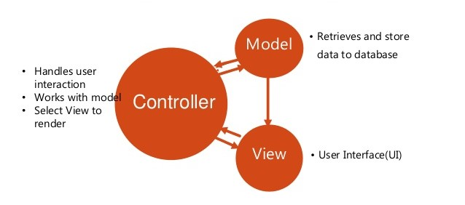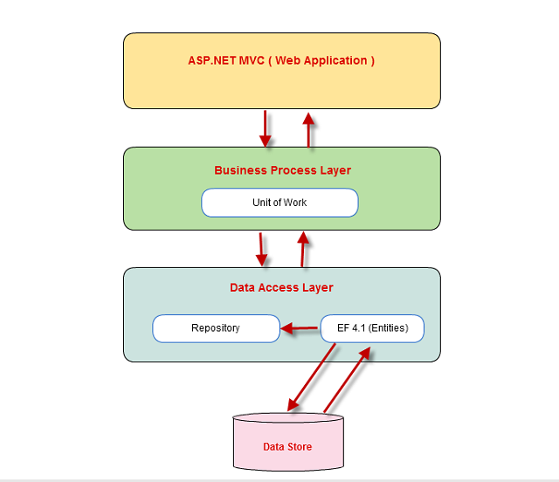

Presentation)

EF 4.5.X(Entities)

## Presentation Tier:

Is the tier in which the users interact with application . Presentation Tier contents Model, View, Controller used to receive a request and response to User.

Technology: ASP.NET MVC4, Razor, HTML, CSS, JavaScript, Ajax, JQUERY, Twitter Bootstrap

## Business Logic Tier:

Is mainly working as the bridge between Data Tier and Presentation Tier. All the Data passes through the Business Tier before passing to the Presentation Tier.

Technology: OOP, ASP.NET

## Data Access Tier:

Is basically the server which stores all the application’s data .Data tier contents Database Tables, Database Views and other means of storing Application Data .

Technology: SQL Server, LINQ, ADO.NET

# Algorithms - Data Flowchart:

## Symbol generates:



## Login process:

Start

Admin page

Staff page

End-user page

Input username & password

Validate account exist ?

Admin logged in page

Staff logged in page

End-user logged-in page

End

Show error message

exist

exist

exist

Not exist

## Log out:

Start

Homepage

Clear Session

Confirm?

End

yes

no

## Create new user (Admin only):

Start

Input information

Check username duplication ?

exist

Show error message

Not exist

Generate and encode default password

save

Data

base

End

## View list of user account (Admin):

Start

End

Show list of users

Get information from database

## Search specific user account:

Start

Input username

Show error message

Check username exist

Not exist

exist

Show account details

End

## View detail, block/unblock user (Admin only):

Start

Get specific user

Unblock user

Block user

View user details

Confirm action ?

no

yes

Data

base

End

## Reset to default password for specific user (Admin only):

no

save

yes

Generate and encode default password

Confirm action ?

Reset user’s password

Get specific user

Data

base

End

Start

## Create new facility (Facilities head):

Start

Input information

Check FacilityID duplication ?

Duplicate

Show error message

Not duplicate

Data

base

End

## Block/unblock facility (Facilities head):

Start

Confirm action ?

Get specific facility

Unblock facility

Block facility

no

yes

Data

base

Insert the reason

End

## View list of all requests (Facilities head):

End

Show list of all requests

Get information from database

Start

## Assign request to assignee (Facilities head):

Start

Get specific request

Choose an assignee to send this request

no

Confirm action ?

yes

Data

base

End

## Close/Reject request (Facilities head, assignee):

Start

Get specific request

Close/Reject

Confirm action ?

no

yes

Insert the reason

Data

base

End

## Create request (End-user):

Input information of request

Start

Confirm to send ?

no

yes

Data

base

End

## Cancel request (End-user):

Get specific request

Cancel

Start

no

Confirm to cancel ?

yes

Data

base

End

# Data flow diagram (DFD):

Define: Data Flows Diagram (DFD) describes the information flow in the system. The next step of system analysis is to consider in detail the information necessary for the implementation for functions discussed above and the one necessary for the improvement of the functions. Modelling tool frequently used for this purpose is DFD. DFD will support 4 main activities:

Analysis: DFD is used to determine requirement of users.

Design: DFD is used to map out plan and illustrate solution to analysis and users while designing a new system.

Communication: one of the strength of DFD is its simplicity and ease to understand to analysts and users;

Document: DFD is used to provide special description of requirement and system design. DFD provide an overview of key functional components of the system but it does not provide any detail on these components. We have to use other tools like database dictionary, process specification to get an idea of which information will be exchanged and how.

The main components of Context Diagram:

|  |  |  |
| --- | --- | --- |
|  | External | The external factors: External factors can be a person, a group of persons or an organization that are sources of information for the systems and are where system products are transferred to.  The process: Shows the common function of system  The data flow: Describe the movement of information from one part of the system to another.  The data store: The Data Store is used to model a collection of data packets at rest. A store is represented graphically by two parallel lines. The name of a Data Store that identifies the store is the plural of the name of the packets that are carried by flows into and out of the Data Store |
|  | The process |
|  | Data flow |
|  | Data store |

## Context level diagram:

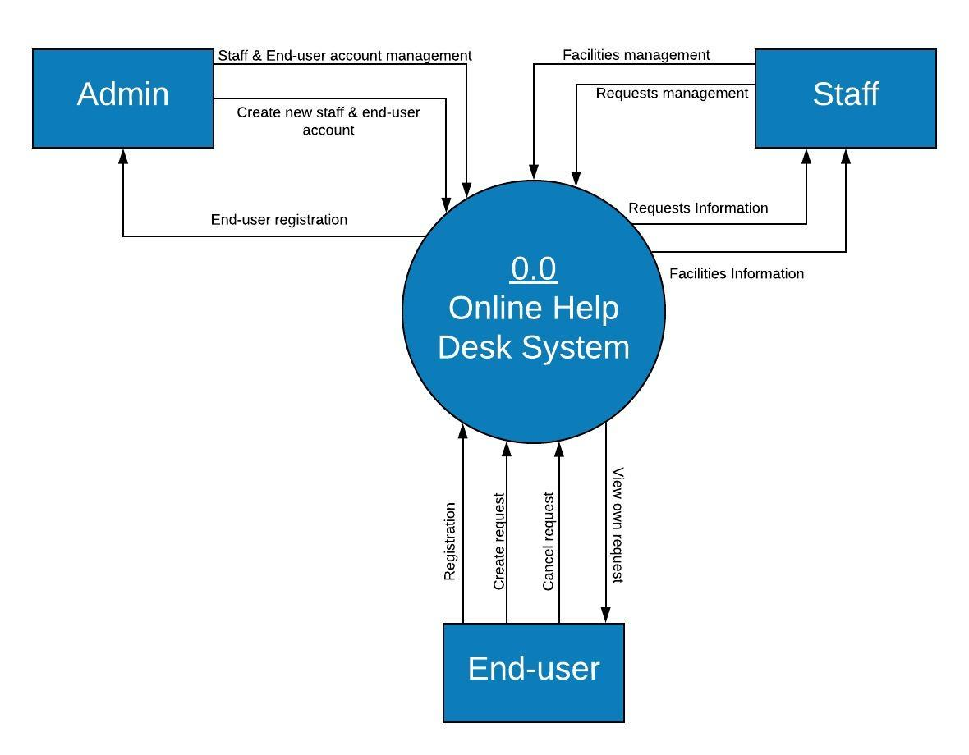

## Level 1 DFD:

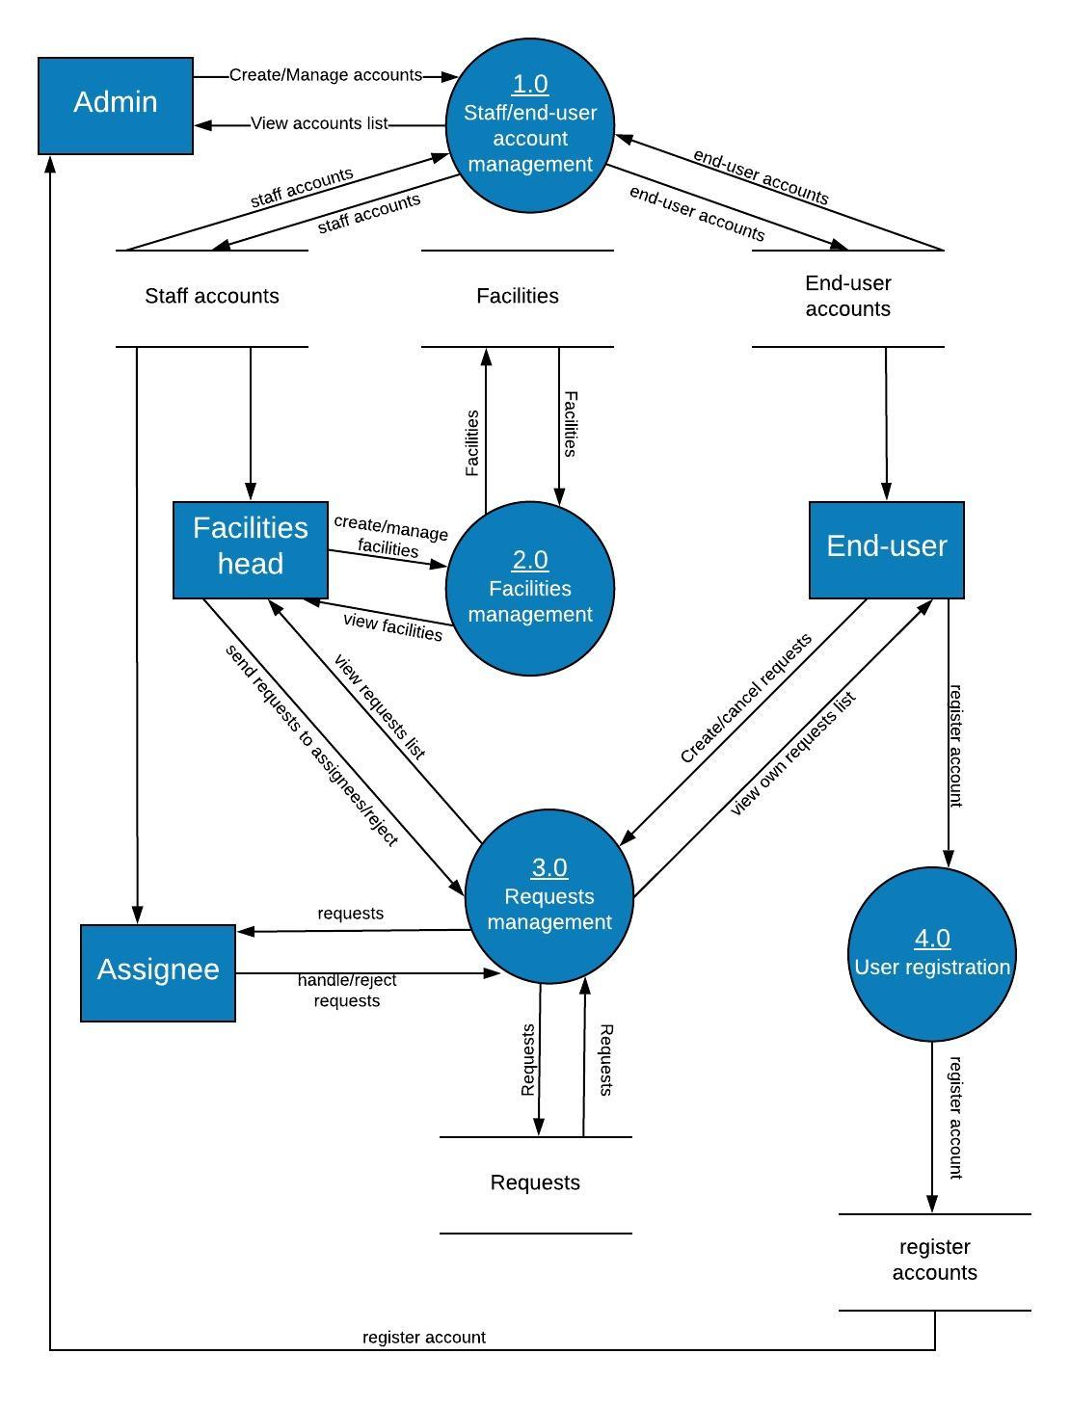

## Level 2 DFD:

### Administrator manages end-user accounts:

1.1  
Create

1.3  
Block/ Unblock

1.2  
Update

Administrator

End-user accounts

### Administrator manages staff accounts:

2.1  
Create

2.3  
Block/ Unblock

2.2  
Update

Administrator

Staff accounts

### Administrator handles registration accounts:

Registration accounts

Administrator

3.1  
Create

End-user accounts

### Facilities head (staff) manages facilities:

4.1  
Create

4.3  
Block/ Unblock

4.2  
Update

Facilities head

Facilities

### Facilities head (staff) manages request:

5.2  
Reject

5.1  
send to assignee

Facilities head

Requests

### Assignee (staff) manages request:

6.2  
Reject

6.1  
Update status

Assignee

Requests

### End-user manages request:

7.2  
Cancel

7.1  
Create

Assignee

Requests

# Use Case Diagram



Online help desk system



Administrator

Facilities Head (Staff)

Assignee (Staff)

End-User

## Administrator Use Case:

<<extend>>

<<extend>>

<<extend>>

<<extend>>

<<extend>>



Administrator

## Facilities Head Use Case:

<<extend>>

<<extend>>

<<include>>

<<extend>>



<<extend>>

Facilities head

## Assignees Use Case:

<<extend>>

<<extend>>



Assignee

## End-user Use Case:

<<extend>>

<<extend>>



End-user

# Entity Relationship (E-R) Diagram

## Entity

Staffs:

Staffs

End-user:

Endusers

Request:

Requests

Admin:

Admin

StaffReply:

Replies

Register:

Register

Facility:

Facilities

## E-R Diagram:

|  |
| --- |
| Register  Facility  1  1  1  1  n  1  1  Has  Has  Request  Has  StaffReply  Admin  Staffs  End-user |

# Class Diagram

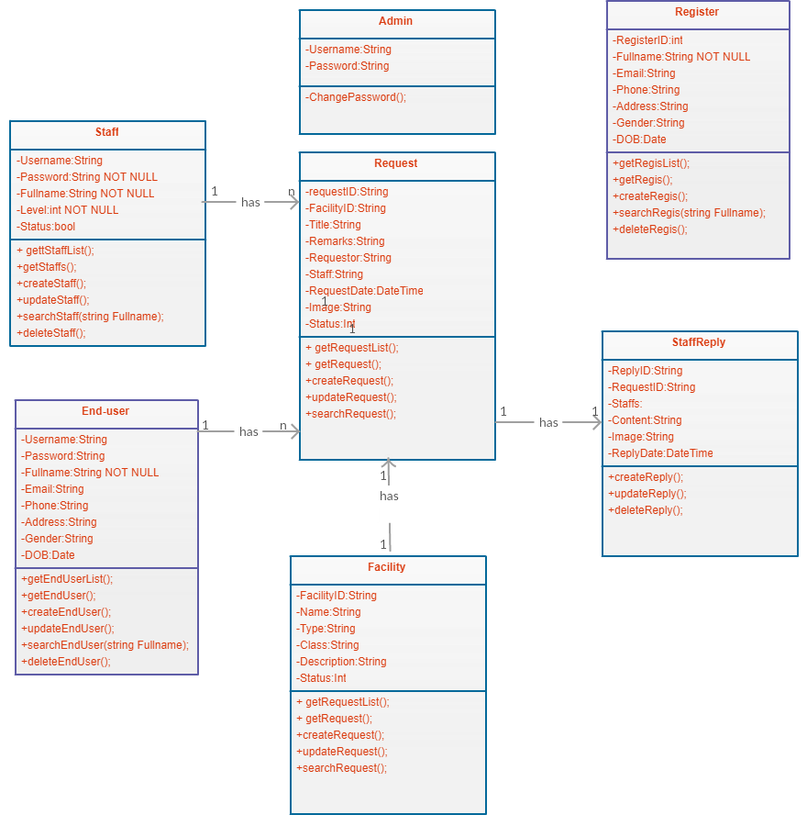

# **Task sheet review 2**

|  |  |  |  |  |  |
| --- | --- | --- | --- | --- | --- |
| Project Ref. No: 4 | Project Title:  Railway Reservation Manage System | Date of Preparation of Activity Plan | | | |
| No. | Task | Actual Start Date | Actual Days | Team Member Names | Status |
| 01 | Architecture & Design of the Project | Oct ,28,2018 | 5 | All Members | Completed |
| 02 | Algorithms - Data Flowchart | All Members | Completed |
| 03 | USE CASE DIAGRAM | All Members | Completed |
| 05 | Sequence DIAGRAM | All Members | Completed |
| 06 | Entity Relationship (E-R) Diagram | All Members | Completed |
| 07 | Class DIAGRAM | All Members | Completed |
| 08 | Task Sheet | All Members | Completed |

|  |  |  |
| --- | --- | --- |
|  | Prepare By: Group 7 | Approved By: Faculty |
| Date: Nov,2, 2018 | Team Leader  Nguyen Hoang Tu | Tran Phuoc Sinh |

REVIEW III

# Database Design:

## Database design diagram:

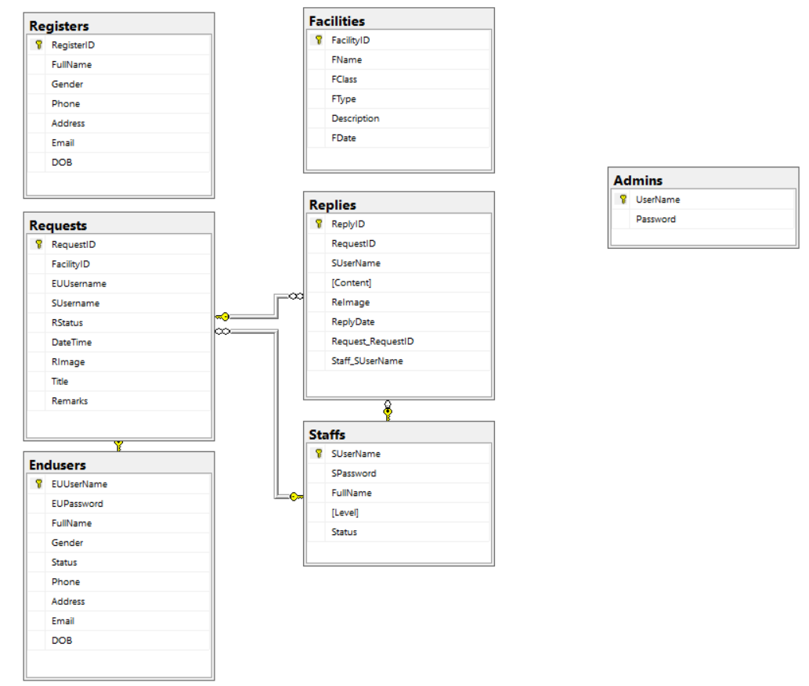

## 2. Structure diagram:

|  |  |  |  |  |  |  |
| --- | --- | --- | --- | --- | --- | --- |
| Admin | | | | | | |
| No. | Field Name | Data Type | Null | Key | Reference Table | Description |
| 1 | UserName | String | No | P |  | Unique |
| 2 | Password | Varchar(50) | No |  |  | Store password of Admin |

*Table Admin

|  |  |  |  |  |  |  |
| --- | --- | --- | --- | --- | --- | --- |
| Staff | | | | | | |
| No. | Field Name | Data Type | Null | Key | Reference Table | Description |
| 1 | SUserName | String | No | P |  | Unique |
| 2 | SPassword | Varchar(50) | No |  |  | Store password of Staff |
| 3 | FullName | Varchar(50) | No |  |  | Store full name of Staff |
| 4 | Level | int | No |  |  | Store level of Staff |
| 5 | Status | Bool | No |  |  | Store status of Staff |

*Table Staff

|  |  |  |  |  |  |  |
| --- | --- | --- | --- | --- | --- | --- |
| Endusers | | | | | | |
| No. | Field Name | Data Type | Null | Key | Reference Table | Description |
| 1 | EUUserName | String | No | P |  | Unique |
| 2 | EUPassword | Varchar(50) | No |  |  | Store password of End-User |
| 3 | FullName | Varchar(50) | No |  |  | Store full name of End-User |
| 4 | Gender | Varchar(10) | Yes |  |  | Store gender of End-User |
| 5 | Status | Bool | No |  |  | Store status of End-User |
| 6 | Phone | Varchar(20) | Yes |  |  | Store phone of End-User |
| 7 | Address | Varchar(50) | Yes |  |  | Store address of End-User |
| 8 | Email | Varchar(50) | No |  |  | Store email of End-User |
| 9 | DOB | String | Yes |  |  | Store birth day of End-User |

Endusers Table

Facilities Table

|  |  |  |  |  |  |  |
| --- | --- | --- | --- | --- | --- | --- |
| Facilities | | | | | | |
| No. | Field Name | Data Type | Null | Key | Reference Table | Description |
| 1 | FacilityID | String | No | P |  | Unique |
| 2 | FName | Varchar(50) | No |  |  | Store name of Facility |
| 3 | FClass | Varchar(50) | No |  |  | Store class of Facility |
| 4 | FType | Varchar(50) | No |  |  | Store type of Facility |
| 5 | Description | Varchar(200) | Yes |  |  | Store description of Facility |
| 6 | FDate | DateTime | Yes |  |  | Store date of Facility |

|  |  |  |  |  |  |  |
| --- | --- | --- | --- | --- | --- | --- |
| Requests | | | | | | |
| No. | Field Name | Data Type | Null | Key | Reference Table | Description |
| 1 | RequestID | String | No | P |  | Unique |
| 2 | FacilityID | String | Yes | F |  | Unique |
| 3 | EUUserName | String | No | F |  | Unique |
| 4 | SUserName | String | Yes | F |  | Unique |
| 5 | RStatus | int | No |  |  | Store status of Request |
| 6 | DateTime | DateTime | No |  |  | Store date of Request |
| 7 | RImage | String | Yes |  |  | Store image of Request |
| 8 | Title | Varchar(50) | No |  |  | Store tile of Request |
| 9 | Remark | Varchar(200) | Yes |  |  | Store remark of Request |

Requests Table

|  |  |  |  |  |  |  |
| --- | --- | --- | --- | --- | --- | --- |
| Registers | | | | | | |
| No. | Field Name | Data Type | Null | Key | Reference Table | Description |
| 1 | RegisterID | String | No | P |  | Unique |
| 2 | FullName | Varchar(50) | No |  |  | Store full name of Register |
| 3 | Gender | Varchar(10) | No |  |  | Store gender of Register |
| 4 | Phone | Varchar(20) | No |  |  | Store phone of Register |
| 5 | Address | Varchar(50) | No |  |  | Store address of Register |
| 6 | Email | Varchar(50) | No |  |  | Store email of Register |
| 7 | DOB | DateTime | No |  |  | Store birth day of Register |

Registers Table

Replies Table

|  |  |  |  |  |  |  |
| --- | --- | --- | --- | --- | --- | --- |
| Reply | | | | | | |
| No. | Field Name | Data Type | Null | Key | Reference Table | Description |
| 1 | ReplyID | String | No | P |  | Unique |
| 2 | RequestID | String | No | F |  | Unique |
| 3 | SUserName | String | No | F |  | Unique |
| 4 | Content | String | No |  |  | Store content of Reply |
| 5 | ReImage | int | Yes |  |  | Store image of Reply |
| 6 | ReplyDate | DateTime | No |  |  | Store date of Reply |

# GUI Designs – Front End:

## Enduser Home page:

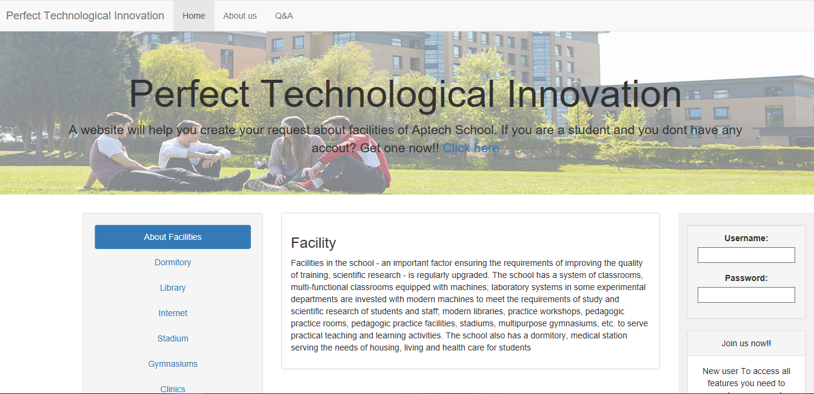

12

11

10

9

8

7

6

5

4

3

2

1

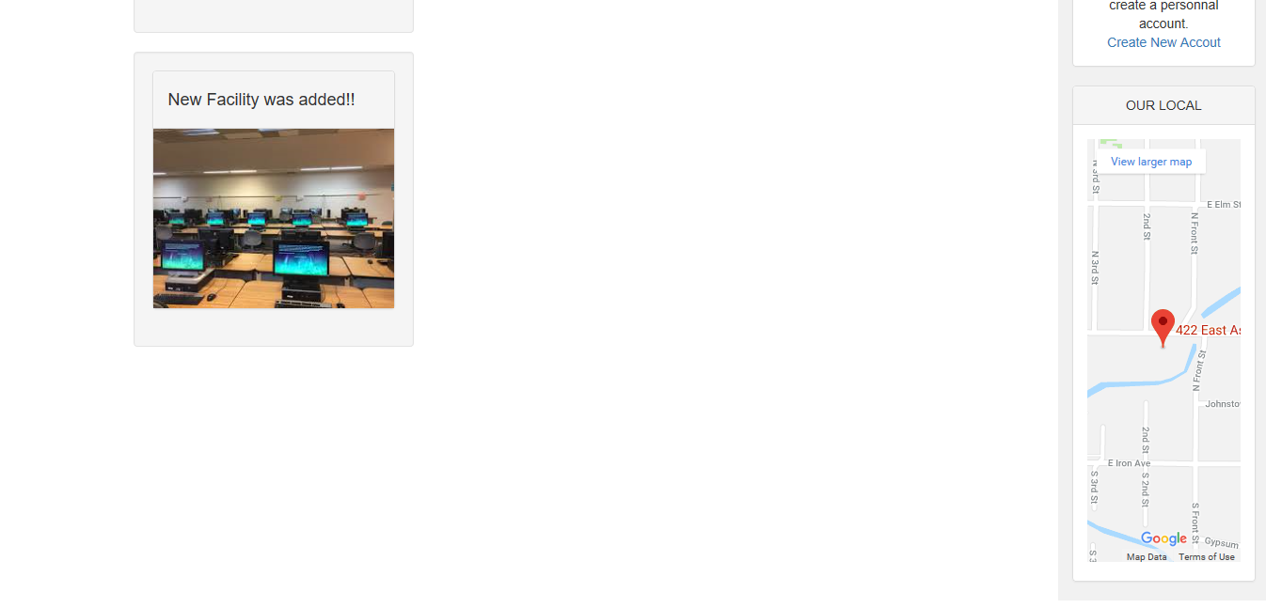

13

|  |  |  |  |  |  |  |
| --- | --- | --- | --- | --- | --- | --- |
| **Home page** | | | | | | |
| **No.** | Name | Type | Validate | Event | Description | Status |
| 1 | Home | Hyper Link |  | Click | Url to Home page action | Enable |
| 2 | About us | Hyper Link |  | Click | Url to Home page action | Enable |
| 3 | Q&A | Hyper Link |  | Click | Url to Home page action | Enable |
| 4 | About Facilities | Hyper Link |  | Click | Url to Home page action | Enable |
| 5 | Dormitory | Hyper Link |  | Click | Url to Home page action | Enable |
| 6 | Library | Hyper Link |  | Click | Url to Home page action | Enable |
| 7 | Internet | Hyper Link |  | Click | Url to Home page action | Enable |
| 8 | Stadium | Hyper Link |  | Click | Url to Home page action | Enable |
| 9 | Gymnasium | Hyper Link |  | Click | Url to Home page action | Enable |
| 10 | Clinic | Hyper Link |  | Click | Url to Home page action | Enable |
| 11 | Username | Text box | Not null | Click | Input username | Enable |
| 12 | Password | Text box | Not null | Click | Input password | Enable |
| 13 | Register | Hyper Link |  | Click | Show Register model | Enable |

## Register page:

## End-user logged in page:

### 3.1 Request list:

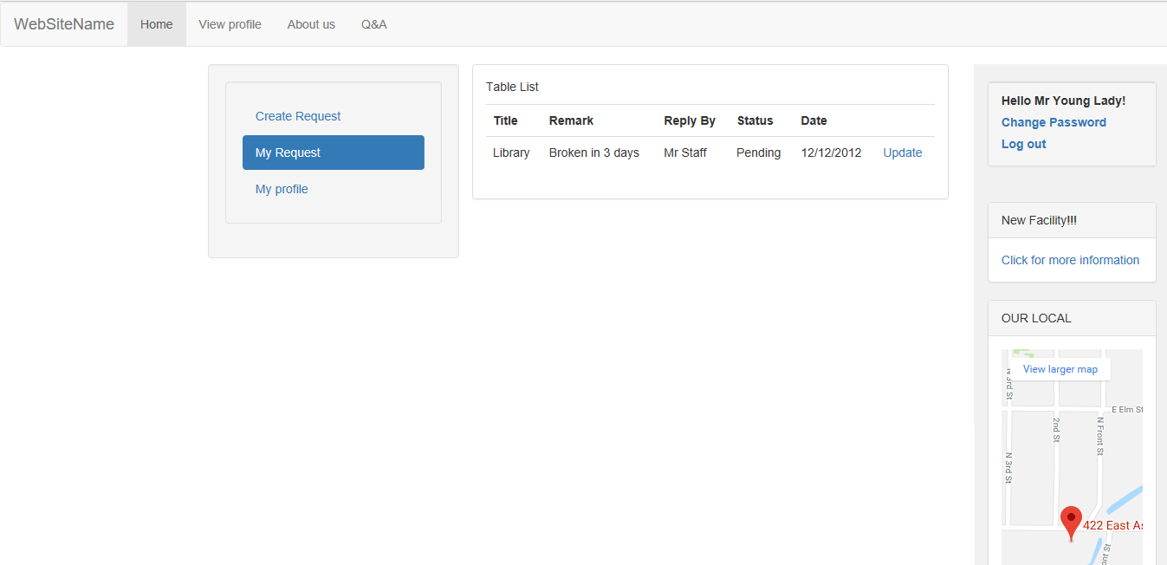

7

6

5

4

3

2

1

|  |  |  |  |  |  |  |
| --- | --- | --- | --- | --- | --- | --- |
| **End-user logged in** | | | | | | |
| **No.** | Name | Type | Validate | Event | Description | Status |
| 1 | Create request | Hyper Link |  | Click | Show Create request form model | Enable |
| 2 | My Requests | Hyper Link |  | Click | Show list of requests | Enable |
| 3 | My Profile | Hyper Link |  | Click | Show My profile form model | Enable |
| 4 | Table List | Table |  |  | List of requests that end-user created | Enable |
| 5 | Update | Hyper Link |  | Click | Show request detail model to update | Enable |
| 6 | Change password | Hyper Link |  | Click | Show change password model | Enable |
| 7 | Log out | Hyper Link |  | Click | Log out and return to Home page | Enable |

### Create new request:

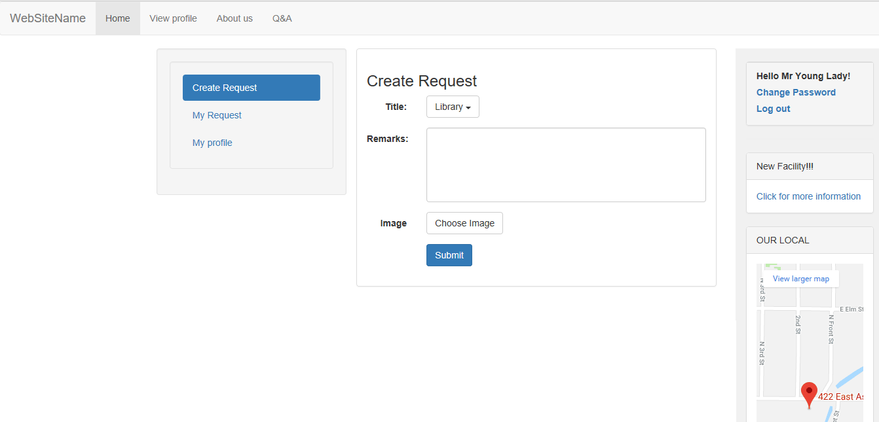

1

2

3

4

|  |  |  |  |  |  |  |
| --- | --- | --- | --- | --- | --- | --- |
| **Home page** | | | | | | |
| **No.** | Name | Type | Validate | Event | Description | Status |
| 1 | Title | Combo box |  | Click | Show list of facility classes | Enable |
| 2 | Remark | Text area | Not null | Click | End-user types description for his/her request | Enable |
| 3 | Choose Image | Button |  | Click | Click to choose an image to make the request more detail | Enable |
| 4 | Submit | Button |  |  | Submit request | Enable |

### 3.3 End-user profile:

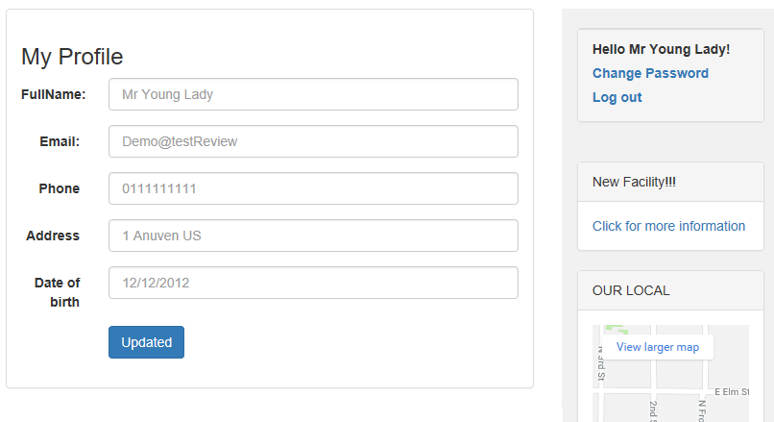

6

5

4

3

2

1

|  |  |  |  |  |  |  |
| --- | --- | --- | --- | --- | --- | --- |
| **Home page** | | | | | | |
| **No.** | Name | Type | Validate | Event | Description | Status |
| 1 | Full name | Text box | Not null | Click | End-user full name | Enable |
| 2 | Email | Text box | Not null | Click | End-user email | Enable |
| 3 | Phone | Text box | Not null | Click | End-user phone number | Enable |
| 4 | Address | Text box | Not null | Click | End-user address | Enable |
| 5 | Date of birth | Text box | Not null | Click | End-user date of birth | Enable |
| 6 | Update | Button | Not null | Click | Update end-user profile | Enable |

### 3.4 Change password:

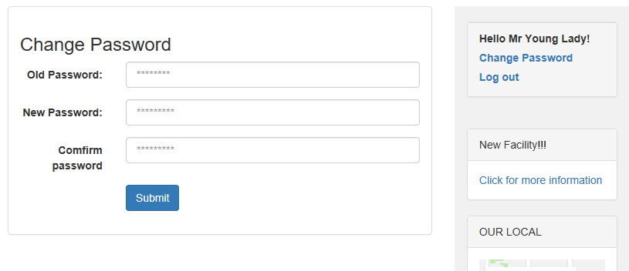

4

3

2

1

|  |  |  |  |  |  |  |
| --- | --- | --- | --- | --- | --- | --- |
| **Home page** | | | | | | |
| **No.** | Name | Type | Validate | Event | Description | Status |
| 1 | Old password | Text box | Not null | Click | Input old password | Enable |
| 2 | New password | Text box | Not null | Click | Input new password | Enable |
| 3 | Confirm password | Text box | Not null-same new password value | Click | Input to confirm new password | Enable |
| 4 | Submit | Button |  | Click | Submit to change password | Enable |

## Facilities head logged in page:

### 4.1 View list of all requests:

5

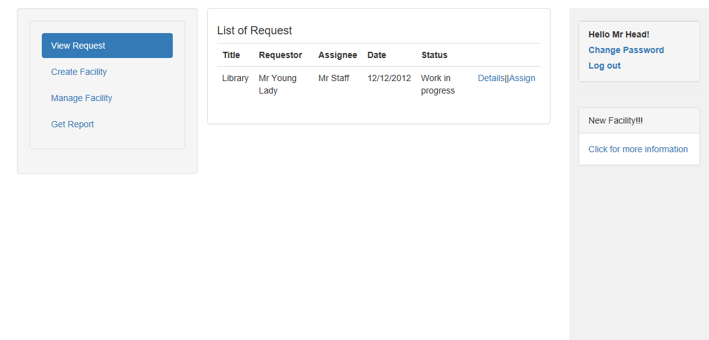

9

8

7

6

4

3

2

1

|  |  |  |  |  |  |  |
| --- | --- | --- | --- | --- | --- | --- |
| **Home page** | | | | | | |
| **No.** | Name | Type | Validate | Event | Description | Status |
| 1 | View request | Hyper Link |  | Click | Show list of all requests | Enable |
| 2 | Create Facility | Hyper Link |  | Click | Show create facility model | Enable |
| 3 | Manage facility | Hyper Link |  | Click | Show list of all facilities | Enable |
| 4 | Get report | Hyper Link |  | Click | Show report once per month/week | Enable |
| 5 | List of requests | Table |  |  | List of all requests |  |
| 6 | Details | Hyper Link |  | Click | Show request details model | Enable |
| 7 | Assign | Hyper Link |  | Click | Show Assign to assignee model | Enable |
| 8 | Change password | Hyper Link |  | Click | Show change password model | Enable |
| 9 | Log out | Hyper Link |  | Click | Log out and return to Head login page | Enable |

### 4.2 Create facility:

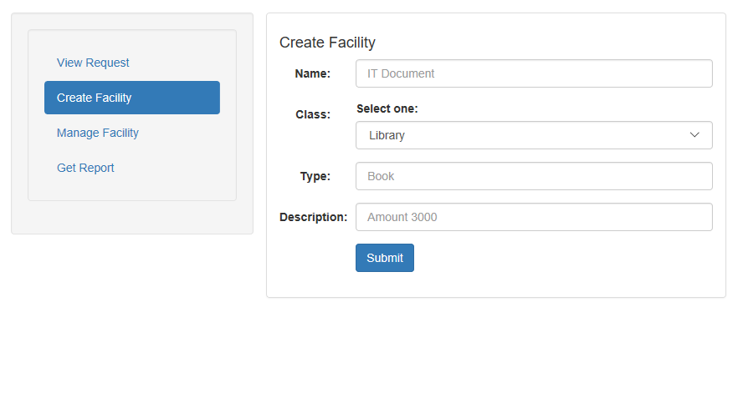

5

4

3

2

1

|  |  |  |  |  |  |  |
| --- | --- | --- | --- | --- | --- | --- |
| **Home page** | | | | | | |
| **No.** | Name | Type | Validate | Event | Description | Status |
| 1 | Name | Text box |  | Click | Input name of new facility | Enable |
| 2 | Class | Combo box |  | Click | Choose a class of new facility | Enable |
| 3 | Type | Text box |  | Click | Input type of new facility | Enable |
| 4 | Description | Text box |  | Click | Input description of new facility | Enable |
| 5 | Submit | Button |  | Click | Submit to create new facility | Enable |

### 4.3 Manage facilities:

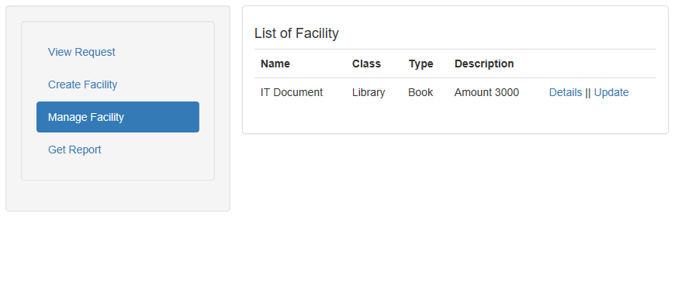

3

2

1

|  |  |  |  |  |  |  |
| --- | --- | --- | --- | --- | --- | --- |
| **Home page** | | | | | | |
| **No.** | Name | Type | Validate | Event | Description | Status |
| 1 | List of facilities | Table |  |  | Show all facilities |  |
| 2 | Details | Hyper Link |  | Click | Show facility details model | Enable |
| 3 | Update | Hyper Link |  | Click | Show Update facility model | Enable |

#### Facility details:

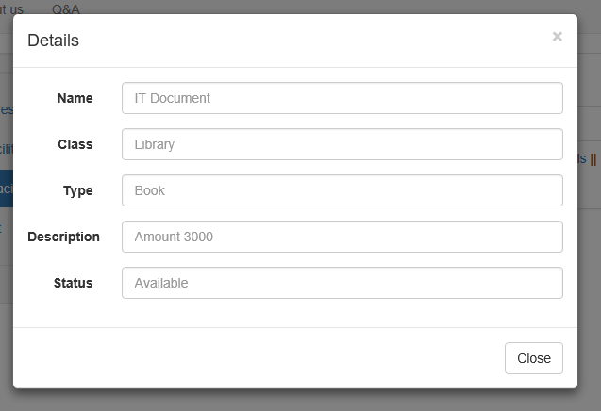

6

5

4

3

2

1

|  |  |  |  |  |  |  |
| --- | --- | --- | --- | --- | --- | --- |
| **Home page** | | | | | | |
| **No.** | Name | Type | Validate | Event | Description | Status |
| 1 | Name | Text box |  |  | Show name of facility |  |
| 2 | Class | Text box |  |  | Show class of facility |  |
| 3 | Type | Text box |  |  | Show type of facility |  |
| 4 | Description | Text box |  |  | Show description of facility |  |
| 5 | Status | Text box |  |  | Show status of facility |  |
| 6 | Close | Button |  |  | Close facility details model | Enable |

#### Update facility:

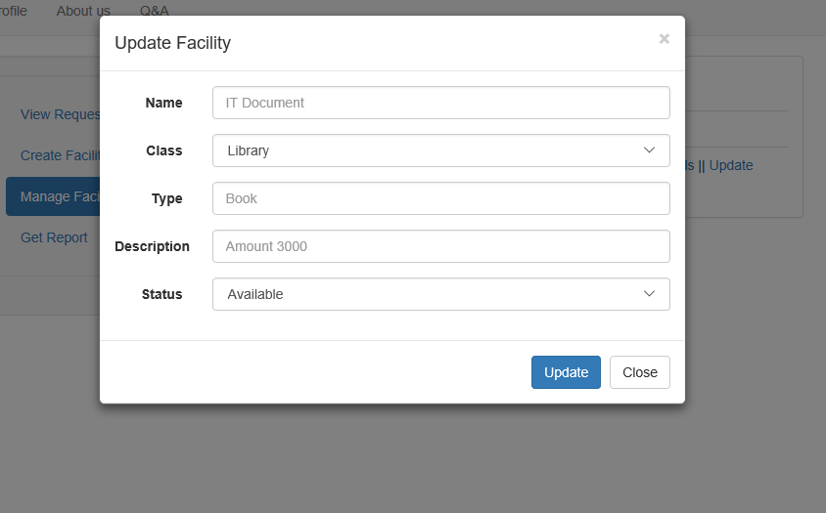

1

2

3

4

5

7

6

|  |  |  |  |  |  |  |
| --- | --- | --- | --- | --- | --- | --- |
| **Home page** | | | | | | |
| **No.** | Name | Type | Validate | Event | Description | Status |
| 1 | Name | Text box |  | Click | Input name of facility | Enable |
| 2 | Class | Combo box |  | Click | Input class of facility | Enable |
| 3 | Type | Text box |  | Click | Choose type of facility | Enable |
| 4 | Description | Text box |  | Click | Input description of facility | Enable |
| 5 | Status | Combo box |  | Click | Choose status of facility | Enable |
| 6 | Close | Button |  | Click | Close facility update model | Enable |
| 7 | Update | Button |  | Click | Click to update facility details | Enable |

### 4.4 Get report:

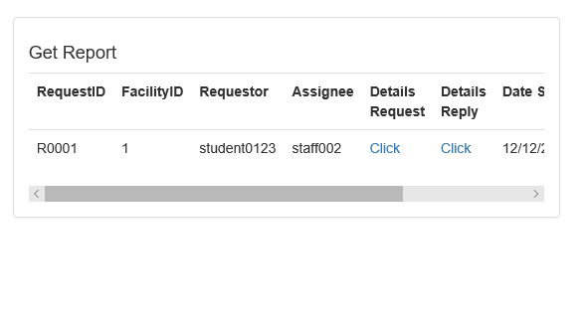

3

2

1

|  |  |  |  |  |  |  |
| --- | --- | --- | --- | --- | --- | --- |
| **Home page** | | | | | | |
| **No.** | Name | Type | Validate | Event | Description | Status |
| 1 | Get report | Table |  |  | Show all details of all request created |  |
| 2 | Details request | Hyper Link |  | Click | View details of request | Enable |
| 3 | Details Reply | Hyper Link |  | Click | View reply details of request | Enable |

## Assignee Logged in page: